DATE: 26.04.2019
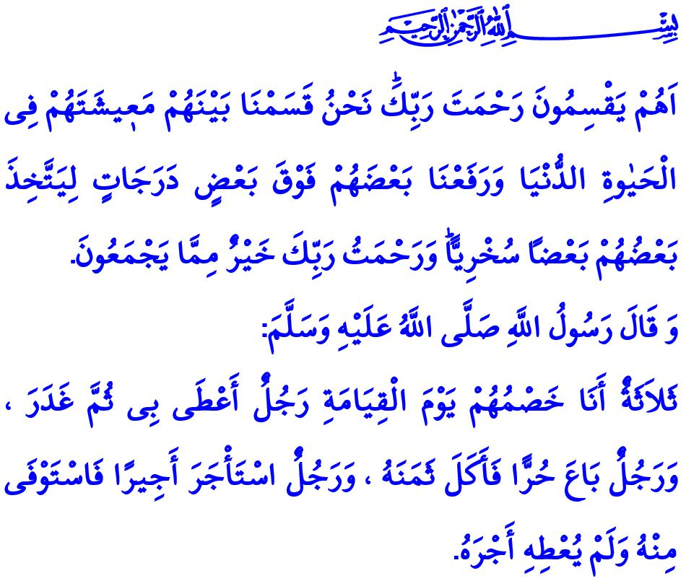
THE BARAKAH OF BUSINESS LIFE:
WORK ETHICS
Dear Muslims!
Humans pursue their rizq (sustenance) in order to ensure the nafaqah (maintenance) of their own and their dependents. With this aim, each person works in jobs in compliance with the sunnatullah imposed by the Almighty Allah (swt). Some people work as employees, others as employers, some others as public servants, and still others as supervisors. There is much wisdom underlying this obligatory division of labor in life. In this regard, the Almighty Allah (swt) states, "Is it they who would portion out the Mercy of thy Lord? It is We who portion out between them their livelihood in the life of this world: and We raise some of them above other ranks, so that some may command work from others. But the Mercy of thy Lord is better than the (wealth) which they amass.”
Honorable Believers!
All people are equal like the teeth of a comb, regardless of their financial status, authority or duty. No one is privileged or superior to the other in terms of being servants of Allah. The superior-subordinate relationship in business life does not give a specific rank to the humans before Allah the Exalted (swt). What makes a person worthy in the presence of Allah (swt) is nothing but his iman, worship, morals, and taqwa (piety). The Prophet Muhammad (saw) warns us, "Allah does not look at your outward appearance and your wealth but He looks only at your hearts and your deeds."
Dear Muslims!
It is a great favor to provide a job for somebody and help them earn their rizq in a halal way and maintain their family. However, this also brings along mutual rights and responsibilities. When these responsibilities are complied with and mutual rights are protected, the people are going to gain the consent of Allah (swt) and the society is going to live in peace and prosperity.
The Messenger of Allah (saw) qualifies the relation between workers and employers, and supervisors and public servants as "brotherhood relation". Love and respect, compassion and mercy, and solidarity and cooperation are essential elements in the relationship between brothers.
Employers who heed the warnings of the Messenger of Allah (saw) observe the rights of their employees. They provide them with a peaceful working environment. They offer them opportunities necessary for their needs such as worship and rest. They pay the amount they deserve on time. They do not task them with duties that they cannot perform. They do not endanger their health and life. They take all necessary measures for occupational safety. They see their employees as a trust and act by knowing that they are accountable to Allah (swt) for them. They establish a brotherly, merciful, warm, and sincere relation with their employees. They do not deprive their employees of their social rights nor victimize them, or employ unregistered workers.
Honorable Believers!
Business life also lays some responsibilities on employees. Muslims work properly in accordance with the advice of the Prophet Muhammad (saw). They protect their workplace, its properties, and materials as their own goods. They do not utilize the facilities of the workplace to satisfy personal needs. They know that when they do not deliver an efficient and a high-quality job this will result in undeserved earning.
Anyone who works for the public service should also see it as entrusted to them by our nation. They should never forget that just as every good deed has its rewards, every negligence and mistake will cause the violation of the rights of individuals and the public.
Dear Muslims!
The Almighty Allah (swt) states in the Holy Qur’an, "It was We who created man, and We know what dark suggestions his soul makes to him: for We are nearer to him than (his) jugular vein. Behold, two (guardian angels) appointed to learn (his doings) learn (and note them), one sitting on the right and one on the left.”
In accordance with this warning of Allah (swt), we need the awareness of servitude in our business life as well as in every area of our lives. Let us all work to produce and earn in halal way. As handicraftsmen and craftsmen, let us not only teach the profession to our apprentices, journeymen, and masters. Let us teach them virtue, honesty, loyalty, and the value of elbow grease and halal earnings at the same time. Let us promote modesty and good morals. Thus, let us hand the business ethics based on Islamic brotherhood and prophetic wisdom down to our generations.
I would like to conclude my khutbah with this hadith qudsi, "Allah the Exalted (swt) states, 'There are three whose adversary I shall be on the Day of Resurrection: a man who has given his word by Me and has broken it; a man who has sold a free man and has consumed the price; and a man who has hired a workman, has exacted his due in full from him but has not given him his wage.’"

Zukhruf, 43/32.
Muslim, Birr, 34.
Qaf, 50/16-17.
Bukhari, Ijarah, 10. General Directorate of Religious Services

